Find Assignment

Mandatory:

1. Search and display all \*.c and \*.h files in all subdirectories starting from current directory

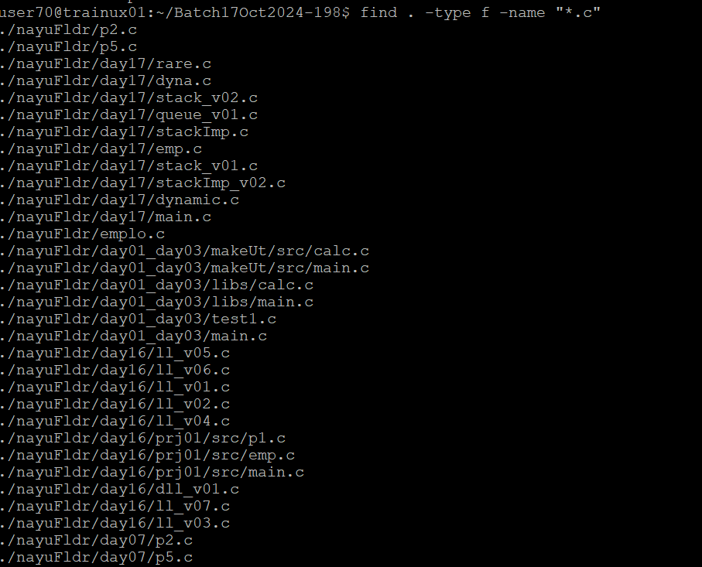

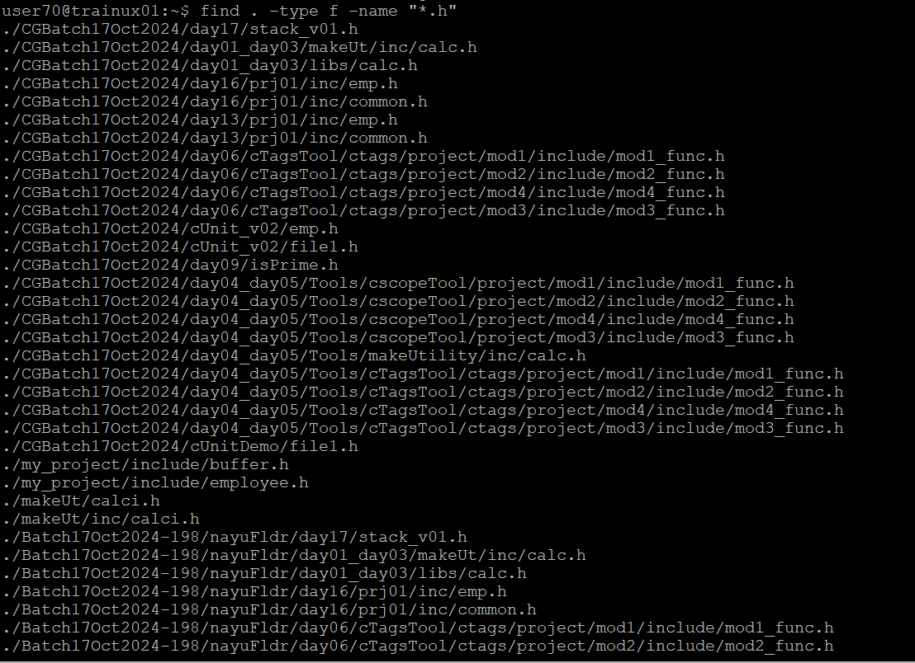

2. Search and display all directories in all subdirectories starting from current director

A. Find . -type d

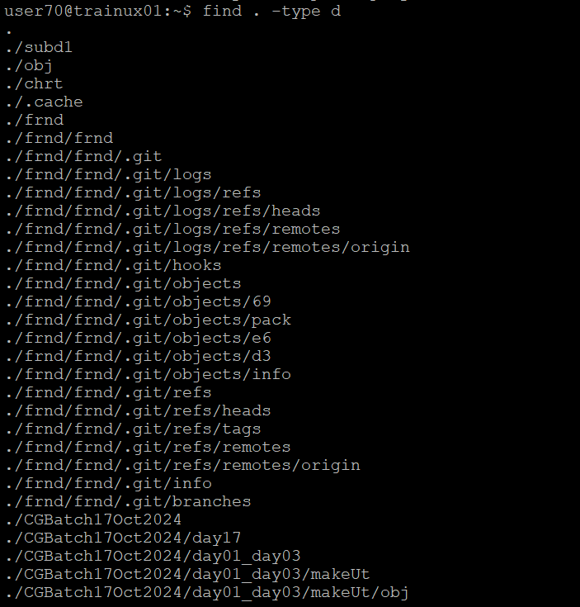

3. Search and display all files with permissions only rw with user

